A [**binary expression tree**](https://en.wikipedia.org/wiki/Binary_expression_tree) is a kind of binary tree used to represent arithmetic expressions. Each node of a binary expression tree has either zero or two children. Leaf nodes (nodes with 0 children) correspond to operands (variables), and internal nodes (nodes with two children) correspond to the operators. In this problem, we only consider the '+' operator (i.e. addition).

You are given the roots of two binary expression trees, root1 and root2. Return true*if the two binary expression trees are equivalent*. Otherwise, return false.

Two binary expression trees are equivalent if they **evaluate to the same value** regardless of what the variables are set to.

**Follow up:** What will you change in your solution if the tree also supports the '-' operator (i.e. subtraction)?

**Example 1:**

**Input:** root1 = [x], root2 = [x]

**Output:** true

**Example 2:**

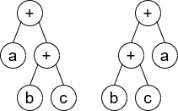

**Input:** root1 = [+,a,+,null,null,b,c], root2 = [+,+,b,c,a]

**Output:** true

**Explaination:** a + (b + c) == (b + c) + a

**Example 3:**

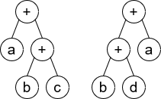

**Input:** root1 = [+,a,+,null,null,b,c], root2 = [+,+,b,d,a]

**Output:** false

**Explaination:** a + (b + c) != (b + d) + a

**Constraints:**

* The number of nodes in both trees are equal, odd and, in the range [1, 4999].
* Node.val is '+' or a lower-case English letter.
* It's **guaranteed** that the tree given is a valid binary expression tree.